**I.T.U.**

**Faculty of Computer and Informatics**

**Computer Engineering**



Lesson name: Computer Communication

Lesson Code: BLG 433E

Name Surname: Abdullah AYDEĞER

Number: 040090533

Instructor’s Name: Sema OKTUĞ

Due Date: 22.11.2012

**What This Report Includes?**

* **Introduction**
* **Classes**
* **Explanation**
* **Efficiency Analysis**

**Introduction**

I’ve used Microsoft Visual Studio 2010 compiler to compile my codes. I wrote my project in C++ language with object oriented approach.

In this homework, FDM(frequency division multiplexing), TDM(time division multiplexing) and CDM(code division multiplexing) is implemented and their advantages and disadvantages are learnt.

**Classes**

* **Station**

Station class is hold characters, which are read from input files, in the transmitDatas vector. CDMChip vector variable in this class is required in the CDM for each station.

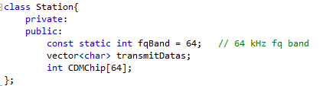

* **Transmission**

Transmission class is needed for holding the variables after multiplexing the transmissed data from station. Variable frequencyInterval is added for determining each station’s frequency interval in FDM. Vector type of ‘c’ variable is used for keeping all transmitted data. Transmit array is used as a sum vector of CDM.

Bandwidth variable is static and given in the homework description.

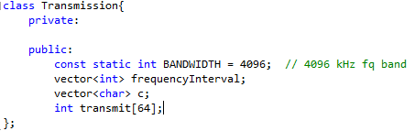

**Explanation**

In the project source code, there are a lot of comments in the necessary parts. I call FDM firstly and FDM multiplexing operation will call FDM demultiplexing and TDM and TDM demultiplexing and similar for CDM.

**Efficiency Analysis**

Efficiency is calculated as

E = Amount of data sent in the corresponding time interval / Max amount of data that line can transmit

I gave the output for efficiency of TDM and FDM in my project.